Examination Committee
REPORT

2023-2024

The National Education Policy (NEP-2020) has brought significant changes to the Indian education system. The policy focused on Interdisciplinary and multidisciplinary learning, emphasizing critical thinking and problem -solving skills. From this session the Kurukshetra University also introduced NEP -2020 in the colleges. The Examination Committee maintains the decorum and quality of the examination and also establishes procedures and instructions for assessing and determining the results of examination under the able guidance of Principal Mrs. Meenu Sharma ji and as per the instructions issued by the Controller of Examinations, Kurukshetra University, Kurukshetra.

The members of the Examination Committee are as follows:
Controller Exams: Dr Renu Baliyan
Co-controller Exams: Ms. Sanjana Raheja (Commerce),
Ms. Lakhwinder Kaur (B.Voc, B.Sc. FD/FT etc.)
Dr. Punam Kundu (Arts),
Dr Shweta Dhawan (Science),
Members:
Science: Dr Nadia Chowhan
Arts: Dr Sunita Salaria, Dr. Swati Sharma, Dr. Suman
Commerce: Ms. Anshul Atreja, Ms. Shilpa
Computers: Ms Divya Vij, Ms. Mamta Atreja
During the present session the Examination Committee established the rules and guidelines as per university rules as:
- Regular meetings organized for the planning and action throughout the session with the Principal mam along with the all the members.
- Creating examination policies as received from the University regarding practical examinations after discussion with the Principal mam.
- Regular notices issued by the committee for absentees, assignments and sessional for both odd and even semesters under the guidance of Principal mam.
- The data of class wise and subject wise strength of UG/PG courses students who were appearing for Theory/Practical examination also submitted to KUK in each semester by the committee.
- Setting of Question Paper of MDC (eleven subjects) in both semesters.
- The evaluation process followed for VAC, SEC, AEC, and MDC as per the guidelines of the University in both semesters.
- ABC Id creation training for teachers organized by Computer department on November, 24, 2023
- Uploading of the Internal Assessment for the odd and even semesters and UG Ist and IInd semesters (major, minor internal assessment including VAC, SEC, AEC, and MDC on the IUMS portal.
- The Internal Assessment for all UG/PG classes prepared/uploading on portal by the concerned teachers under the guidance of examination committee.
- Subjects allotted to the students through the google forms to maintain the transparency and according to their choices in NEP 2020.
- Conducted University Examinations (UG/PG) of college students (odd and even semesters) as well as B.Ed. students (annual examination centre) as per guidelines of KUK in this session.

In this session the Committee organized Annual Prize Distribution Function on 25th September 2023 with great pomp and show, under the able and exemplary guidance of the esteemed principal of the college, Mrs Meenu Sharma, to honour the extraordinary achievements of 300 ( meritorious students comprising of University Merit Holders, Overall Toppers of the College, The Subject Toppers, Best Performer, Best NSS Volunteers, Best NCC Cadets, Best Sports' Person, Best Orator ) students with a wide array of awards in the field of academics and extra-curricular activities. The chief guest for the event was Hon'ble Sh. Sanjay Bhatia, Member of Parliament, Karnal constituency and the Guests of Honour were Smt Renu Bala Gupta, Mayor, Municipal Corporation, Karnal and Mrs. Megha Bhandari, Municipal Councillor, Ward No. 8 Karnal. The college also has a tradition of applauding the strenuous efforts of the faculty members who strive to achieve academic excellence in their respective fields. This year six faculty members were rewarded for attaining the Degree of Doctor of Philosophy in Humanities and Sciences.
The revered chief guest, Hon'ble Sanjay Bhatia, MP, in his speech lauded the efforts of the college in keeping alive the flame of holistic knowledge, innovation, and Vedic wisdom amongst bright young minds. The principal, Mrs Meenu Sharma, in her address said that the college has a rich legacy of academic excellence and efforts are made year after year to buttress it further. She also praised the dedicated efforts of the advisory council of the college, Ms Jyoti Khanduja, Dr Manju Singh, Dr Sangeeta Gaurang, Dr Sushma Thakur and Ms Sunit Bhandari, the convener of the examination committee, Dr Renu Baliyan and the co-conveners, Ms. Sanjana Raheja, Ms Lakhwinder Kaur, Dr Suman, Dr. Punam Kundu and Dr Shweta Dhawan for organizing such a grand event. The event was attended by students and members of both teaching and non-teaching staff.

Some glimpses of Prize Distribution Function 2023-24….
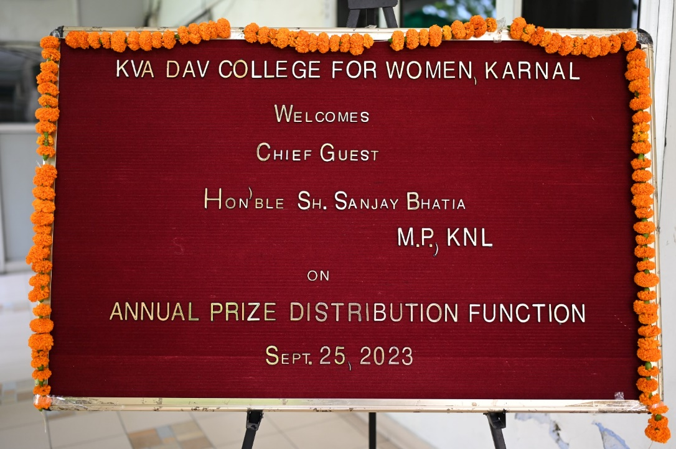
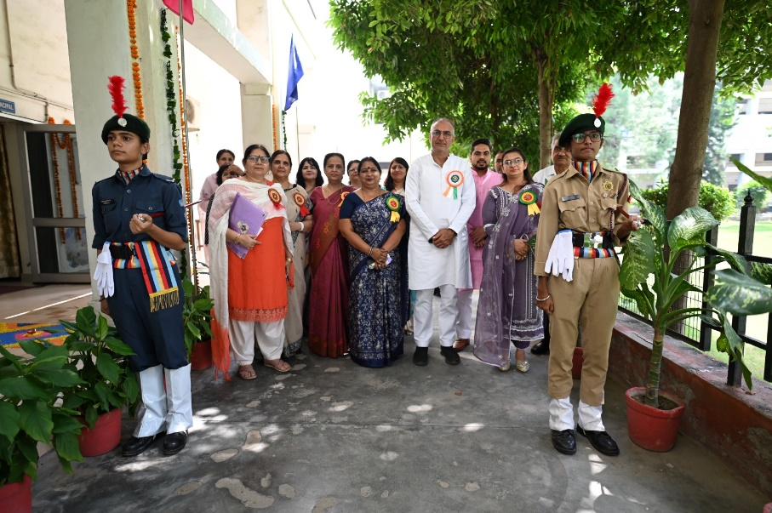
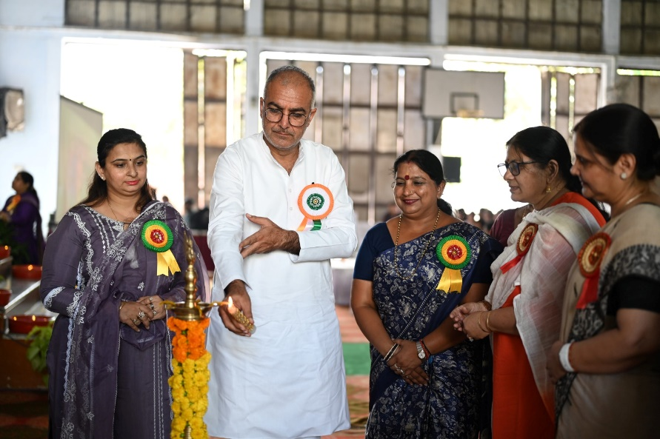
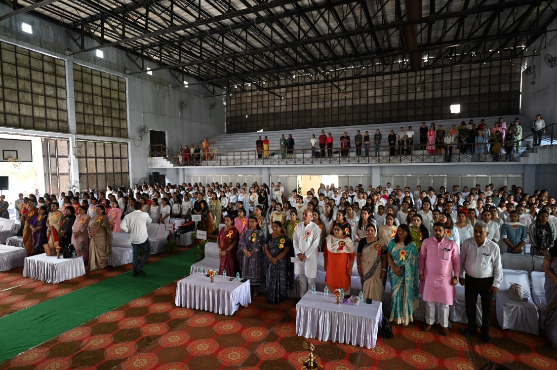
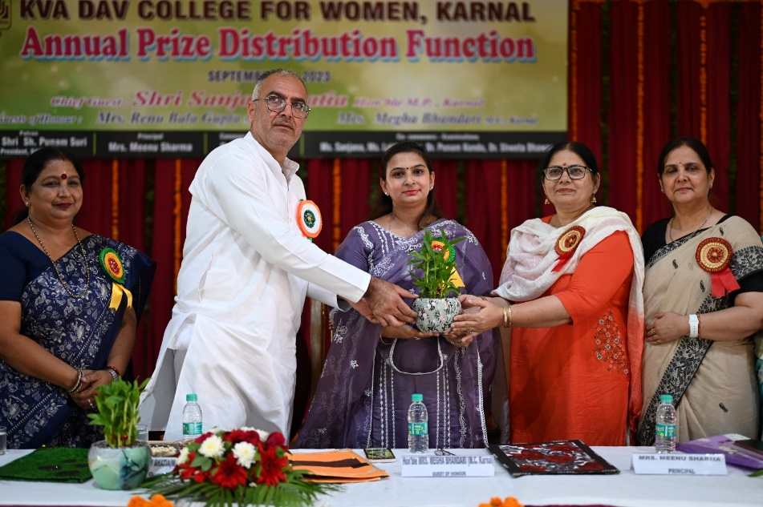
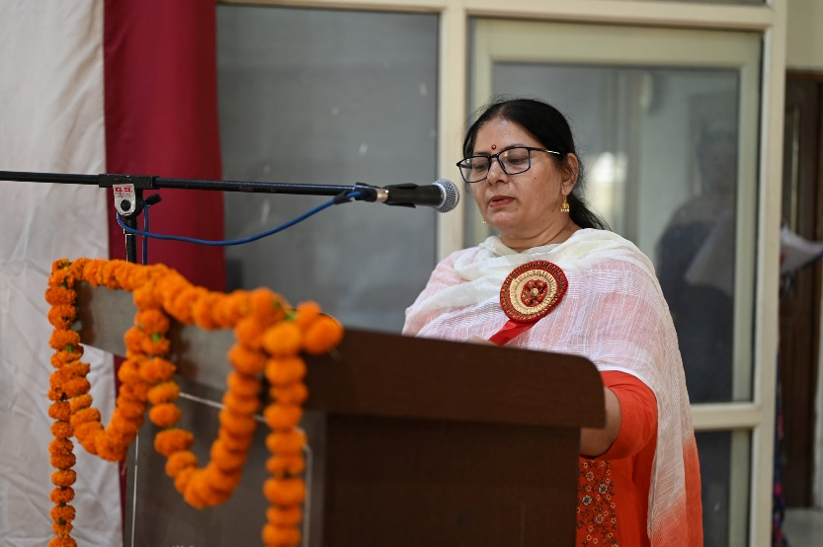
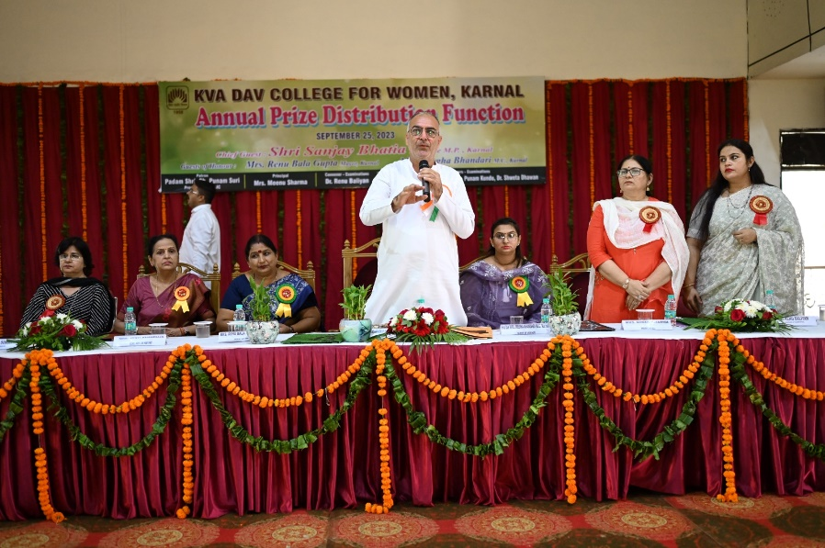
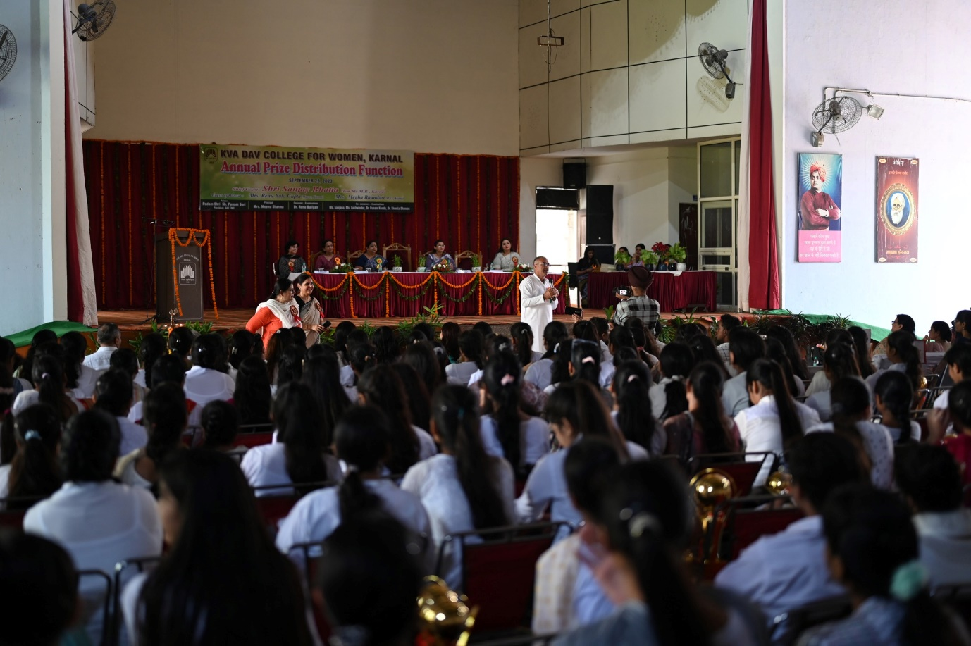
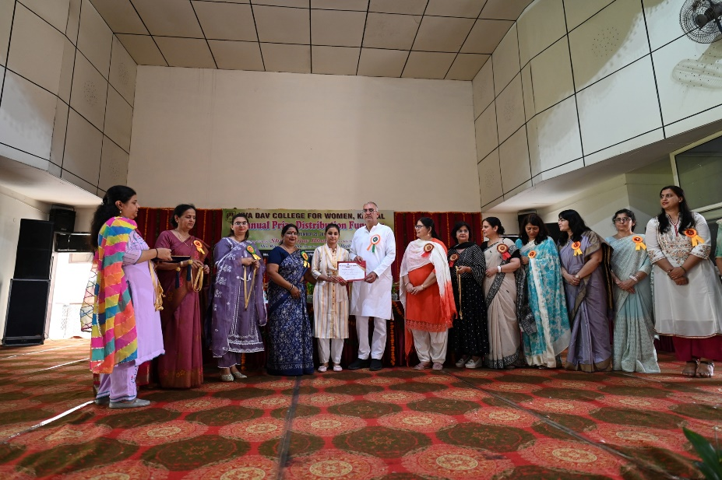
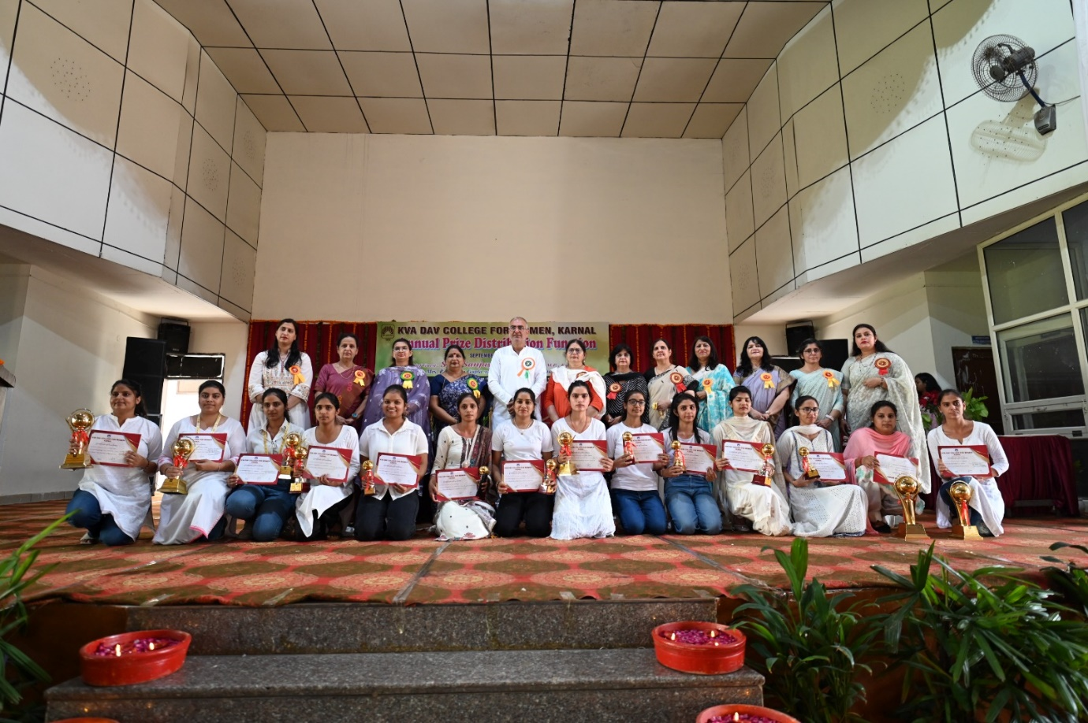
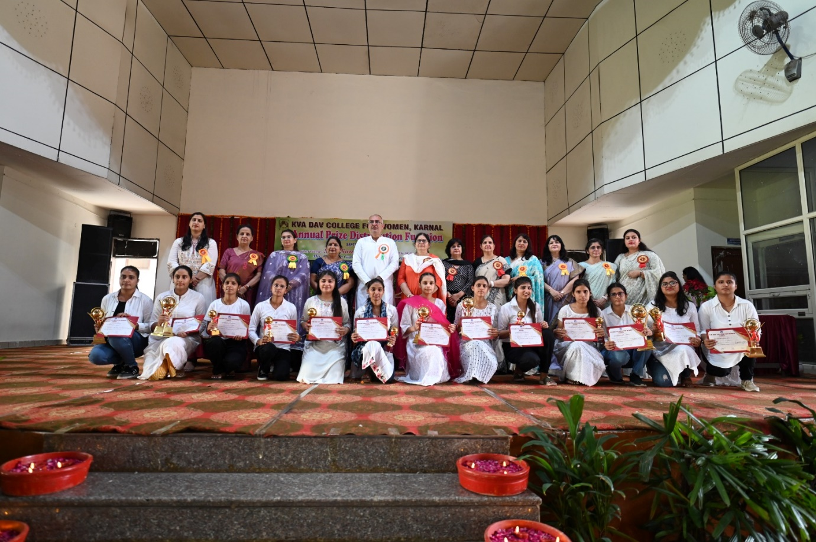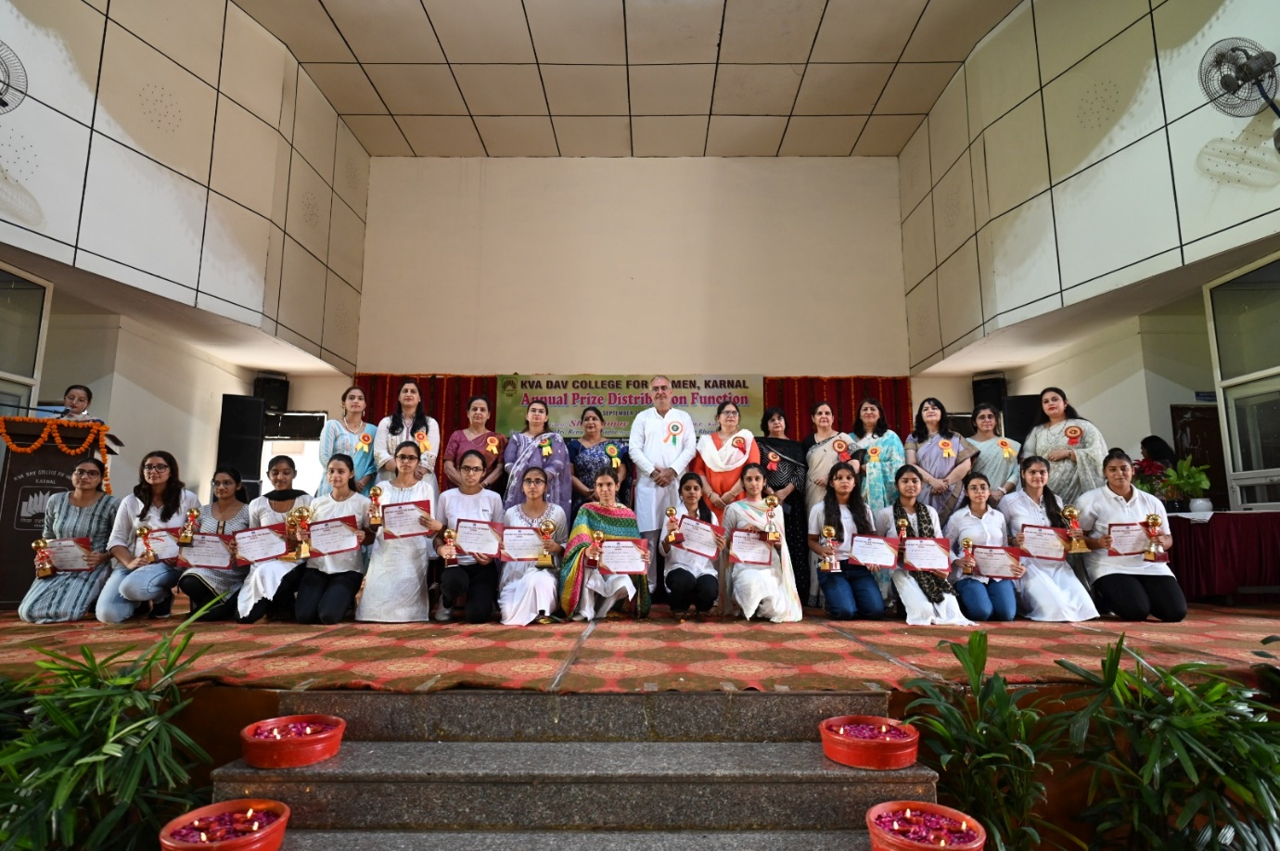
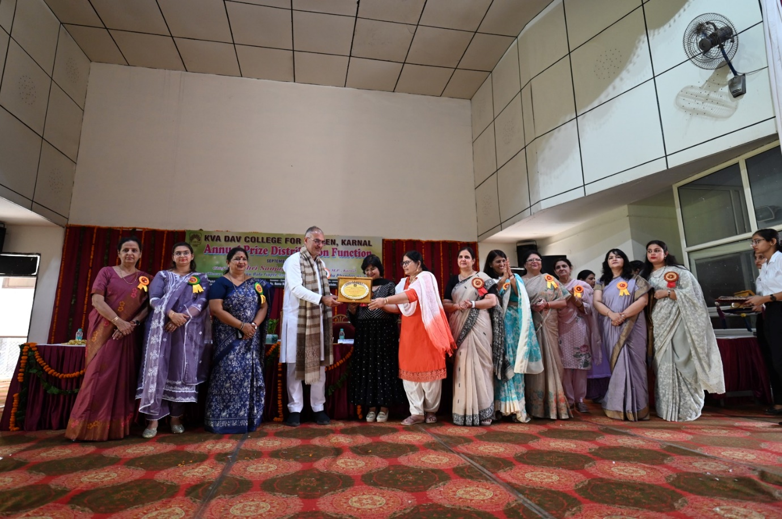

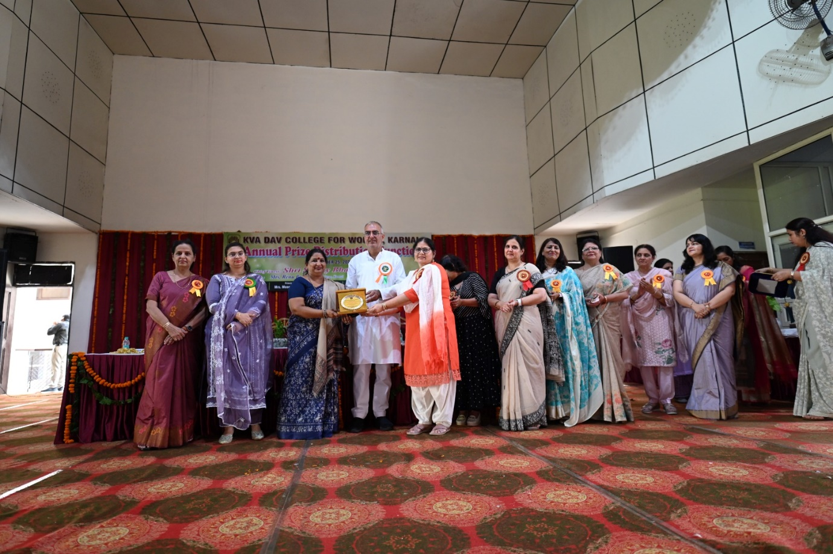
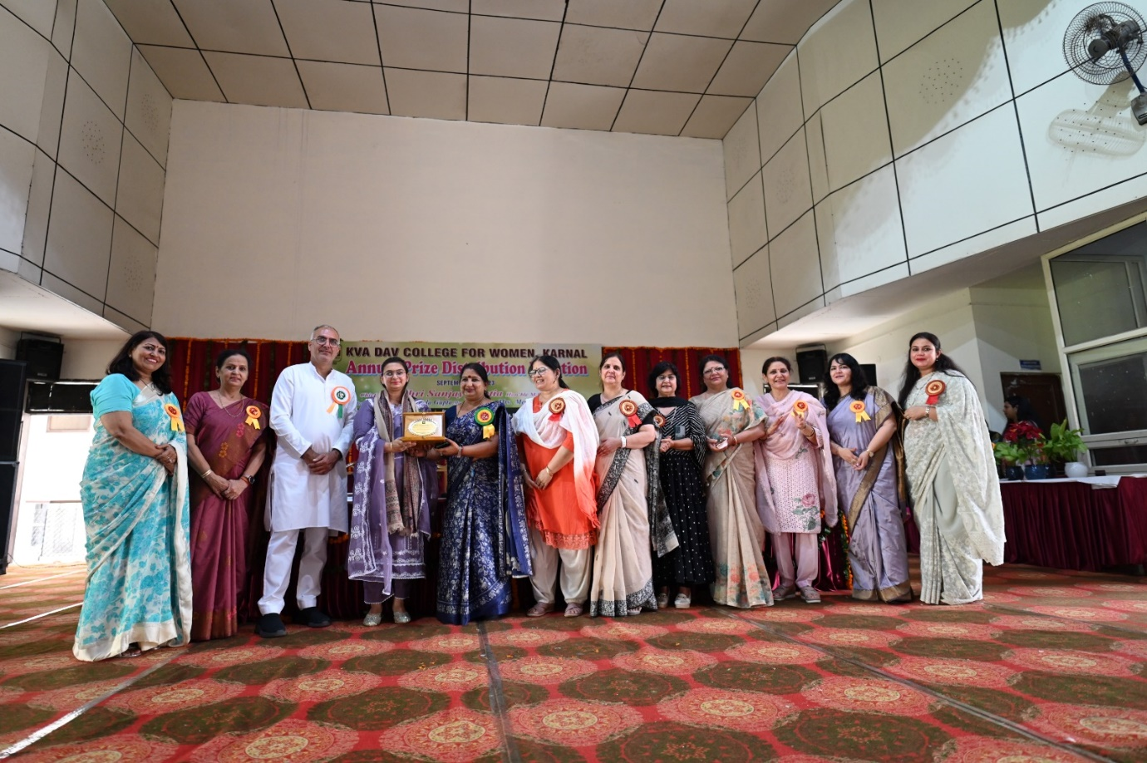

- Ten students of Home Science Department secured positions in Merit list of Kurukshetra University , Kurukshetra in discipline of B.Sc. Fashion Designing. In fourth semester Ms. Priya (Fashion Designing) stood first, Ms. Simranjot stood third and Ms. Deepika stood fifth.
- Also students of final year brought alary to the college- Ms. Yukta Sharma stood first, Ms. Neha second, Ms. Nitya stood fourth, Ms. Akshita and Ms. Rachna stood eighth, Ms. Navneet ninth and Ms. Nisha was at tenth position.

