Activities of Physics Department 2024-2025
*Haryana state council for science and technology, Panchkula organized District level inter college science quiz on 28 august 2024 in Pt. Chiranjilal Sharma govt. P.G college, Karnal.
In this competition two teams of our college participated and were selected for zonal level science quiz competition.
Team 1
Ms. Khushi B.sc-III(Med) 1222022030027
Ms.Lovely B.SC-III(Biotech) 1222023030009
Ms.Shivani B.Sc-II(N.M) 1230528018
Team 2
Ms.Janvi B.Sc-II(N.M) 1230528001
Ms.Payal Rani B.SC-II(N.M) 1230528023
Ms.Chhavi B.sc-II(Biotech) 1232547013
In this competition team1 secured IV th position and Team 2 got Vth position.
Both the teams are selected for zonal level quiz competition.
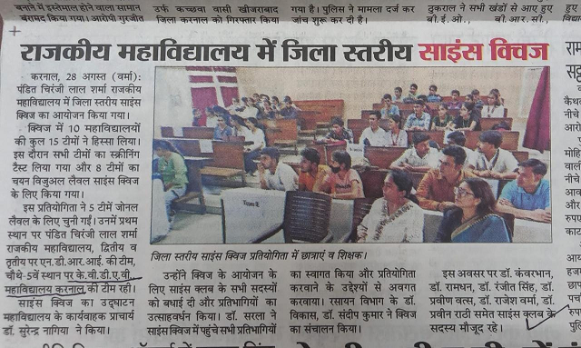

*KVA DAV College for Women, Karnal celebrated INTERNATIONAL OZONE DAY on 16th September 2024 on the theme ozone for life in college campus.
On this day, our respected principal mam addressed the students for the importance of green cover and how it can save our ozone layer from deteriorating and hence saving the whole environment and species.
To mark the importance of ozone cover on our atmosphere a documentary on “the Arctic and the ozone layer” was screened.
To make our effort reach widely, online state level slogan writing contest was also organized.

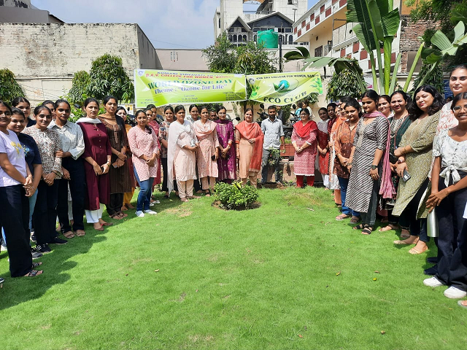
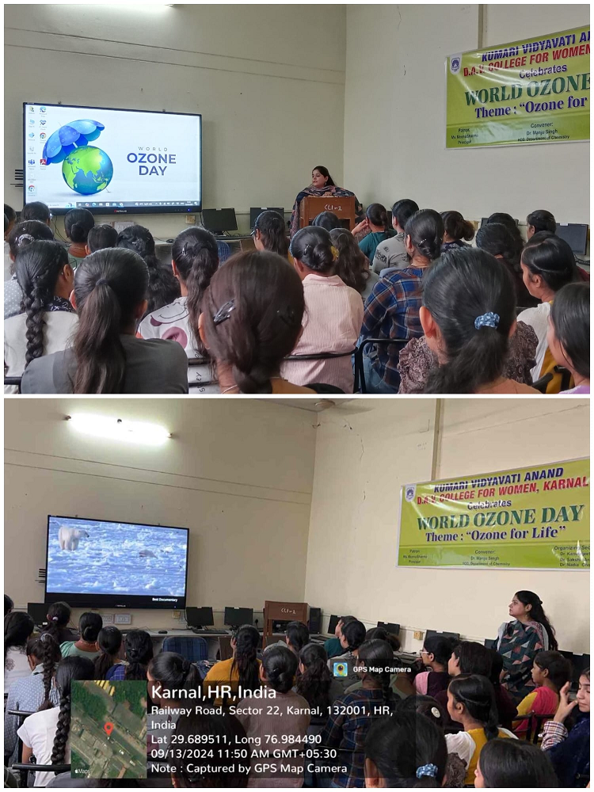

*KVA DAV college for women, karnal organizes Talent show on 27-28 September 2024
Students participated enthusiastically in various events and grabbed position as well. They were awarded with certificate and cash prizes.
Team 1
Ms. Tanisha B.sc(N.M)-II 1230528002
Ms.sania B.sc(N.M)-II 1230528007
Team 2
Ms.Janvi B.sc(N.M)-II 1230528001
Ms.Vanshika B.SC(N.M)-II 1230528021
Ms.Payal B.Sc(N.M)-II 1230528023

Two teams from our department participated in quiz competition team 2 got 2nd position and team 1 secured 3rd position.
Mehakpreet of B.sc(N.M)-I selected as Miss elegant.
Ms.Vanshika Malik Of B.sc(C.S)-III got 3rd position in solo song competition.

*DYAL SINGH COLLEGE, Karnal organized District level science essay writing competition under the aegis of “ Haryana state council for science innovation and technology on 19 October, 2024
One students of our department secured IVTH position .
Ms. Janvi B.sc-N.M II 1230528001

*GVM girl college, sonipat organized Zonal level science quiz contest of Rohtak division for college students of karnal district 2024-25 on 12th November,2024
Two teams from our college Participated in this contest
Team A
Ms.Janvi B.Sc-II(N.M) 1230528001
Ms.Payal Rani B.SC-II(N.M) 1230528023
Ms.Chhavi B.sc-II(Biotech) 1232547013
Team B
Ms. Khushi B.sc-III(Med) 1222022030027
Ms.Lovely B.SC-III(Biotech) 1222023030009
Ms.Shivani B.Sc-II(N.M) 1230528018
Team B secured 3rd position and selected for state level science quiz contest.

*Govt. College for Women, Karnal organizes District level science Exhibition on 1 feb, 2025 organised by DGHE Haryana, Panchkula.
Vanshika Malik of B.sc-III(C.S) and Palak of B.sc-III(N.M) participated in this competition and presented their model on livestock techno-farm they got 2nd position .
Also palak from B.sc-IV(N.M) Bagged the prize as best presenter.

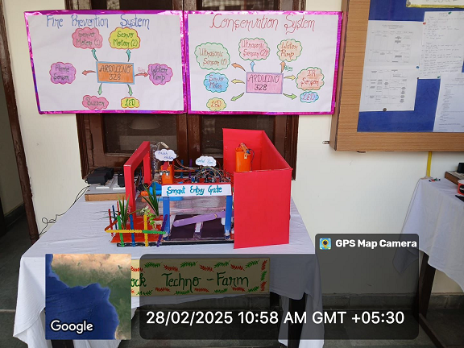

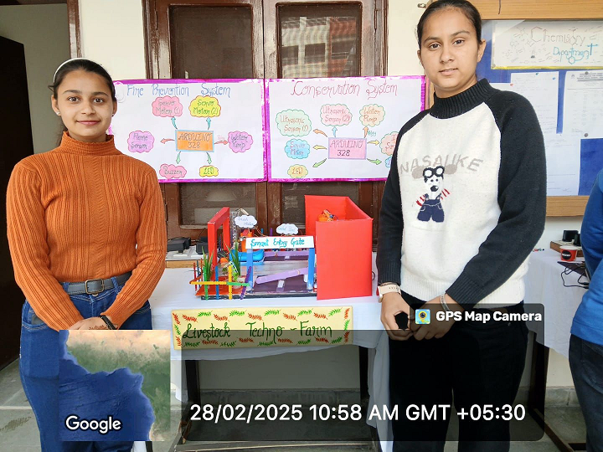

*KVA DAV College foe women , Karnal celebrated ‘National science day’ on 28 feb, 2025 on theme “Empowering Indian Youth for Global Leadership in Science and innovation for vikisit Bharat”.
The Events of the day are as follows-
*Interactive science Exhibition
* Tree Plantation
*Science Documentary Movie
*Interactive session on Internship under NEP-2020
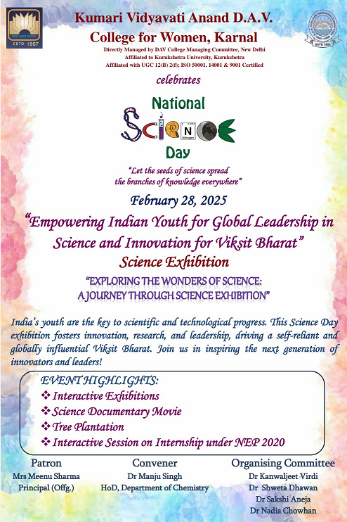
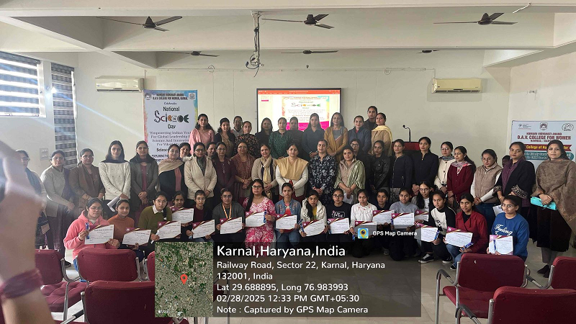

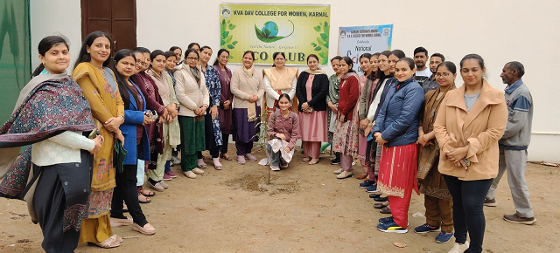

*G.V.M girls College, sonepat celebrated National Science Day on 28 feb,2025
On this Day, the college organizes various competitions
Two students of our department participated in these competitions
Ms.Samikha of B.Sc-III(N.M) Participated in Poster making competition and
Ms. Nandini of B.sc-II(N.M) Participated in declaramation contest
They received the certificate of Participation. And our college also won the overall winning trophy.
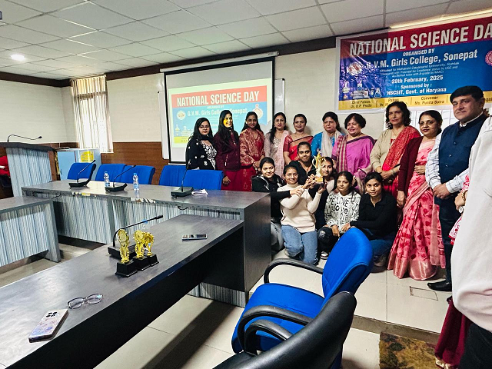
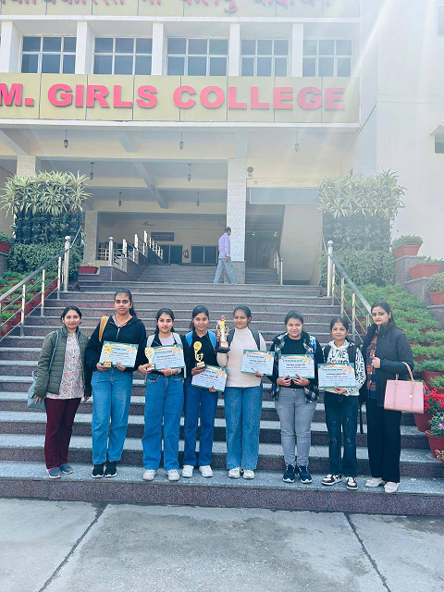

*S.D(P.G) College Panipat celebrated State Level National science day on 28th feb and 1st march 2025.
On 28 th feb,2025 paper and ppt presentation competition was held.
In this competition, two students of our department participated
Ms. Sakshi of B.sc-II(C.S) and Ms.Tanya of B.sc-II(N.M)
From which Sakshi grabbed 2nd position.
On 1st March,2025 Science Quiz competition was held.

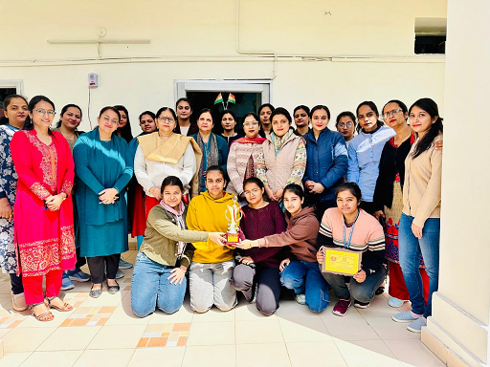

*Dyal Singh College,Karnal organizes State Level Science essay writing competition
The 10 short listed candidates of district level science essay writing competition participated in this contest.
One student of our department Ms.Janvi of B.sc-II(N.M) got the certificate of participation.

*Dyal singh college, Karnal organizes state level science quiz competition for the year 2024-25
One team from our college participated in this competition
Ms. Khushi B.sc-III(Med) 1222022030027
Ms.Lovely B.SC-III(Biotech) 1222023030009
Ms.Shivani B.Sc-II(N.M) 1230528018
They got 4th position.

Meritious students of physics department 2023-24
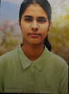  Neha devi  210035647  5th sem-81%  6th sem-82.5% | 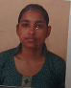  Muskan devi  210035645  5th sem-84%  6th sem-83% | 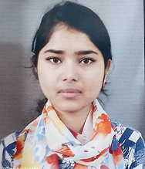Anuwara  210035634  6th sem-81.5% | 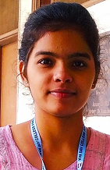sakahi  2023132801  1st sem-85%
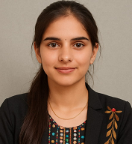Hanshika  2023132802  2nd sem-82% | 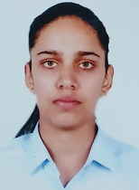sania  2023132828  1st sem-82% | 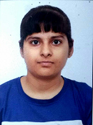  Janvi  2023132816  1st sem-82% | 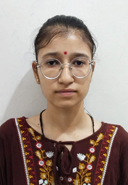  Tanisha  2023132832  1st sem-86%

Shiwani
2023132829
1st sem-90%
2nd sem-84%

